WHY FORM FOLLOWS FUNCTION IS NOT A UI DESIGN PRESCRIPTION
- 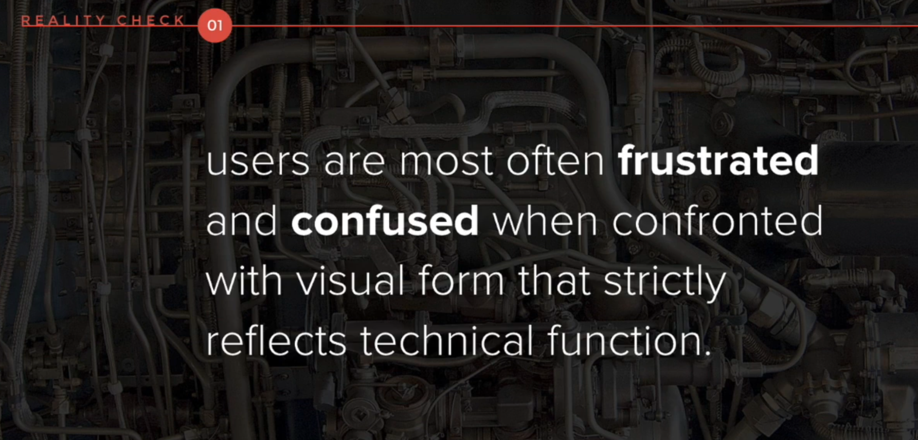
- visual form that strictly reflects technical function is most times scary and daunting
- 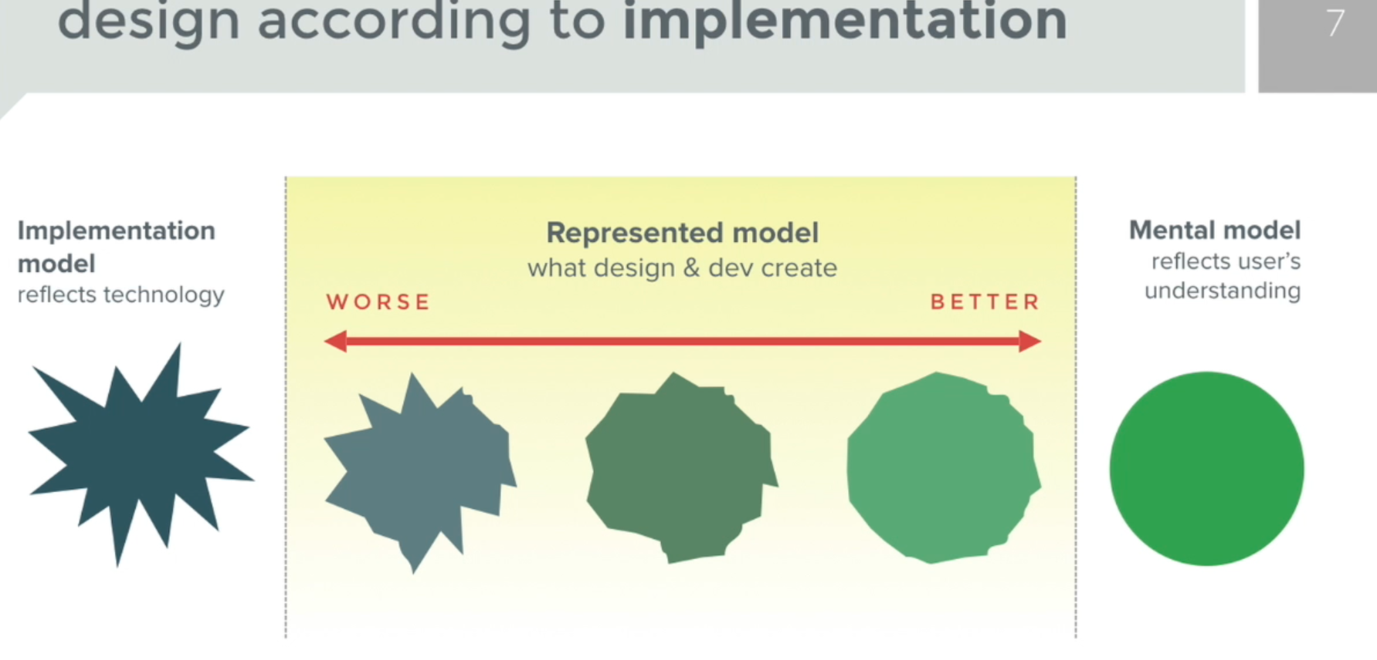
- Book recommendation: About Face by Alan cooper
- implementation model is development, build centric
- mental model is based user’s experience only, what a user will be most familiar and comfortable with
- the closer the build is to the mental model the better the user experience, the closer it is to the implementation model the worse the user experience, like a light switch; if you see a naked light switch it terrifies you, if you see a clean light switch you’re familiar with you’d be more comfortable turning the lights on. In other words a build is incomplete without proper design accounting for user experience
- 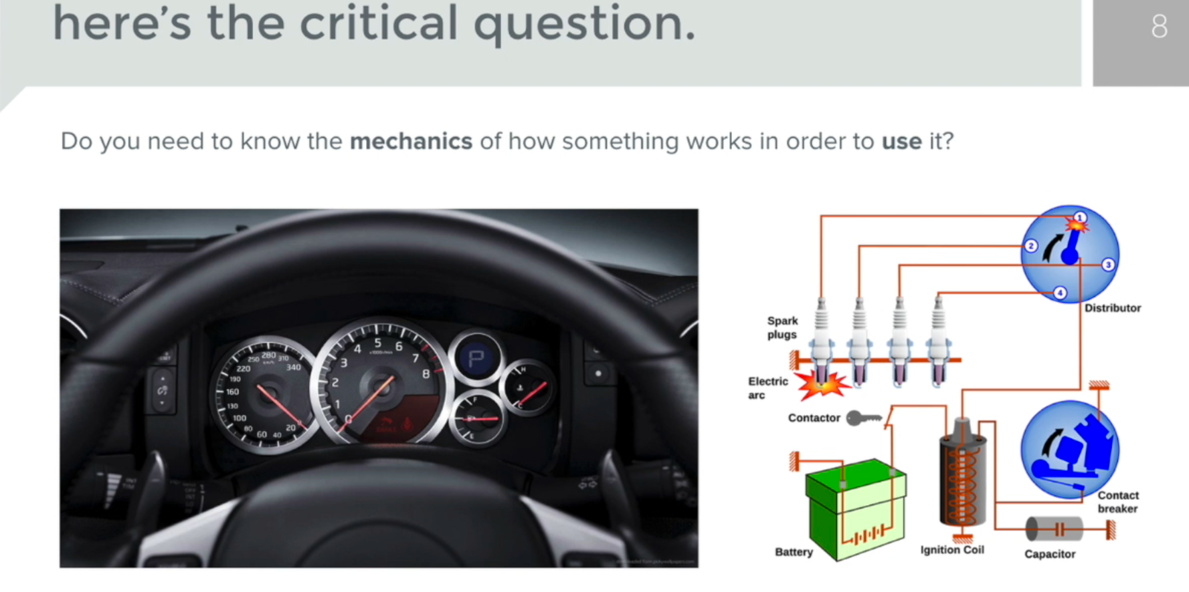
- You don’t need to understand automotive engineering to drive a car
- 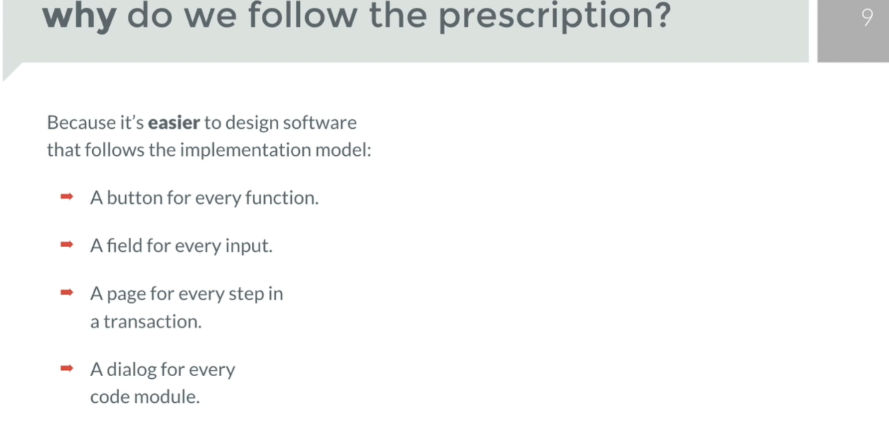
- a build based on every functionality is a bad design, even if it is pretty
- 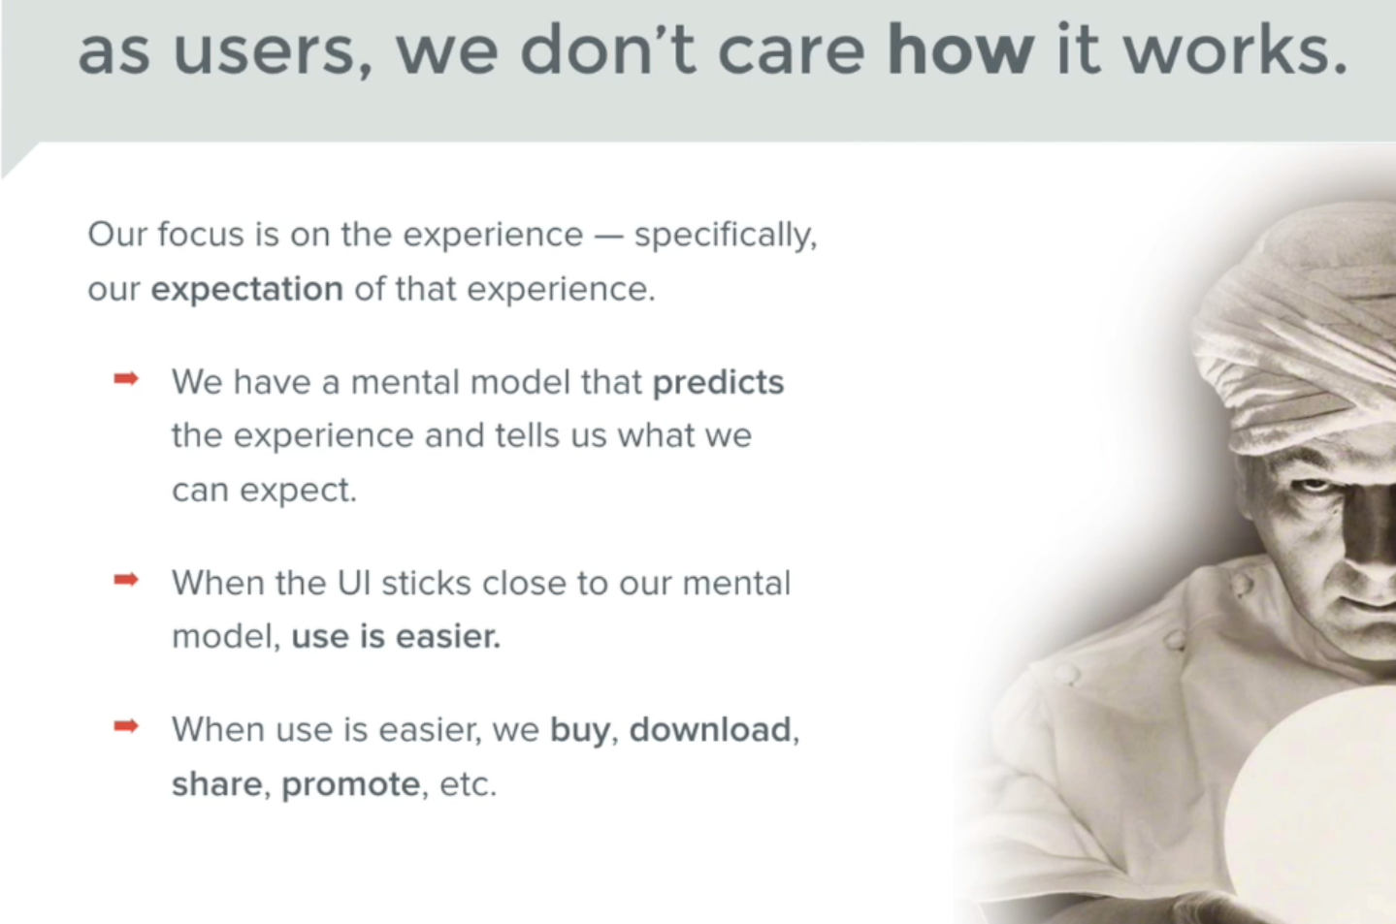
- users only use things when they’re easy to use and understand, while also being able to fully comprehend the value of what they’re using

- 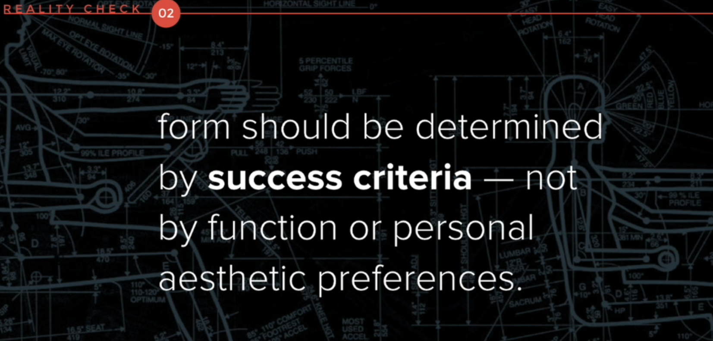
- But what constitutes succes tho?
- 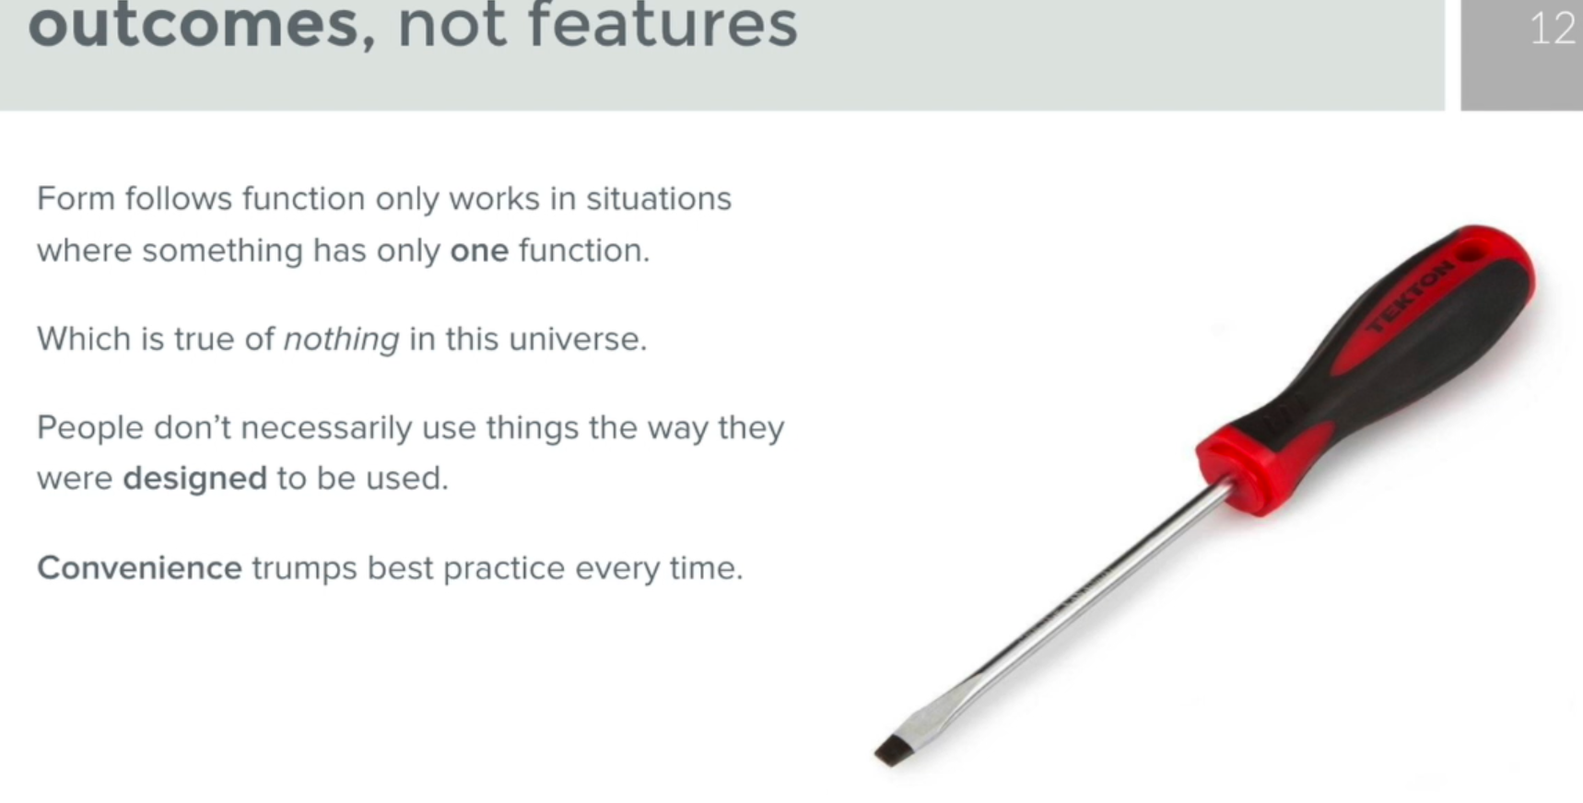
- 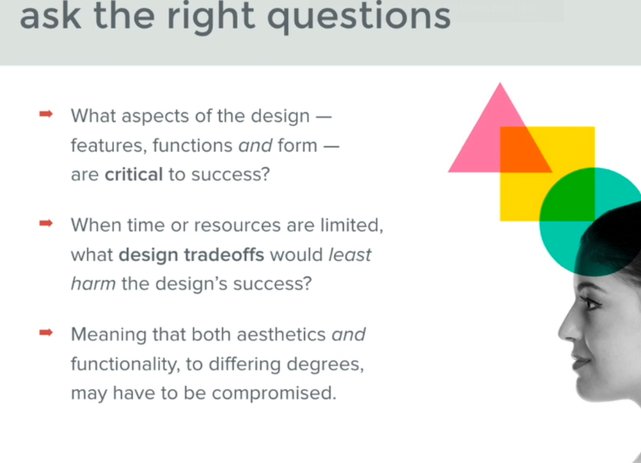
- trade-offs are necessary when considering the success of the product
- 
 

